3. ANNEXURE
I. FORM OF BID
(To be submitted in duplicate)
(Only on Bidder’s Letterhead)
Tender No: CSCL/JS/2026

The Chairman
Departmental Procurement Committee
Ceylon Shipping Corporation Ltd,
No.27, MICH Building,
Sir Razik Fareed Mawatha,
Colombo 01.

BIDDING FOR THE PROVISION OF JANITORIAL SERVICES FOR HEAD OFFICE CEYLON SHIPPING CORPORATION LTD.TENDER NO: CSCL/JS/2026

Having examined the bidding documents, we offer to provide the services for Janitorial Services for Head office Ceylon Shipping Corporation Ltd, No. 27, MICH Building, Sir Rasik Fareed
Mawatha, Colombo 01. in accordance with the Conditions of Contract, Employer’s Requirements, drawings and activity schedule accompanying this Bid for the Contract Price of Rs……………………………(Rupees …………………………………………………………..) (Without Taxes) per month (30 days)/ or any other sum derived in accordance with the said document.

This Bid and your written acceptance of it shall constitute a binding Contract between us. We understand that you are not bound to accept the lowest or any Bid your receive.
We hereby confirm that this Bid complied with the Bid validity required by the bidding documents and specified in the Bidding Data.

Full Name of the Authorized Person of Bidder :……………………………………….
N.I.C. No :……………………………………....
Common Seal and the Signature of the Authorized Person :……………………………………...

II.ACTIVITYSCHEDULE
Notes on the Activity Schedule Objective
(To be submitted in duplicate)
(Only on Bidder’s Letterhead)
Tender No: CSCL/JS/2026
The Chairman
Departmental Procurement Committee
Ceylon Shipping Corporation Ltd,
No.27, MICH Building,
Sir Razik Fareed Mawatha,
Colombo 01.
Details |  | Unit | Rate per Month
 |  | Unit | Rs. | Cts
1 | Floors
 | All common areas, all common passages stair ways.
1.1 | Sweeping, dusting, mopping and damp mopping | Daily
 | With an all-purpose cleaner.
1.2 | Removing all refuse, fitter, waste paper baskets, dust bins, | immediately
 | Rubbish& disposal goods.
1.3 | Drying and removal of water and tea spills, removal | immediately
of foot marks
etc., from the surface.

1.4 | Cleaning, washing and disinfecting garbage bins. | Daily
1.5 | Polishing of garbage bins. | Daily
1.6 | Vacuum cleaning all carpeted floors | weekly
1.7 | Inspection of carpeted areas and removal of spillage, dirt. | daily
2 | Roof, slab and calling and cleaning maintenance
2.1 | Cleaning and removal of dust | weekly
2.2 | Removal of deposits from the roof and the gutters. | immediately
2.3 | Cleaning gutters | weekly
3 | Windows and partitions
3.1 | Cleaning doors at entrance. | Daily
3.2 | Spot clean with glass spotter solution especially | Daily
 | areas around door push plates
3.3 | Dusting and cleaning all doors, windows and partition including glasses with dry cloth or paper to keep them spotlessly clean | Daily
3.4 | Full wash both sides with glass shampoo and window | Daily
 | Cleaning kit in glass doors. Timber paneling, door frames,
 | fixed glass windows, fan lights, glassed louvers, glassed
 | Partitions and windows sills. In the case of windows only the outside glass.
4 | Cesspits and Ceiling, All common areas, all common
 | passages, staircases
4.1 | Dusting and cleaning cesspits and ceiling | Daily
4.2 | Removal of cobwebs, spiders from the soffits, ceiling | Immediately
 | and walls Pay attention to corners and pergols
4.3 | Dusting & cleaning of lighting fixtures and ceiling fans, tube lights & lamp shades. | Weekly
 | Ensure that lights and fans are switched off before work commences.
5 | Internal walls emulsion painted all common areas, all common passages, all stair cases and pipespieces
 | mentioned in item No. 5
5.1 | Spot clean with general purpose detergent | Daily
5.2 | Cleaning and polishing stainless steel plaques, | Weekly
 | railings, name boards, signs and fire hydrants using
 | suitable chemicals and keep them in good condition
 | at all times.
5.3 | Cleaning and emulsion coated walls & portioned walls | Weekly
 | of hand marks & dirt using suitable compound soap
 | water & sponging off marks
6 | Toilets, wash rooms
6.1 | Sweep & scrub floor with germicidal detergent | 2 times daily
 | such as phenol
6.2 | Remove stains from toilet bowls, urinals, commodes, wash | 4 times daily
 | basins, toilet floors, urinal and wash basin bottle traps and
 | fixtures etc.
6.3 | Cleaning of walls, floors cubide partitions | Daily
6.4 | Clean toilet pans, cisterns, urinals especially around water | 4 times
 | lines using approved toilet cleaners such as phenol. | daily
6.5 | Clean pedestal covers in both sides with disinfectant | Daily
6.6 | Clean down water basins, tap head and cover flow holes. | 4 times
 |  | daily
6.7 | Clean down tilled walls | Daily
6.8 | Clean all bright metal fittings | Daily
6.9 | Brush sink holes and gullies trap | Daily
6.10 | Remove spots from mirrors and stainless steel | Daily
 | fittings and wipe dry
6.11 | Full clean mirrors and glass windows | Weekly
6.12 | Polish all stainless fittings | Weekly
6.13 | Removal of corrosion that may occur | immediately
6.14 | Checkup of toilets and wash room to determine operational | Hourly
 | Condition
6.15 | Clean blockages in wash basins, gullies, urinals | immediately
7 | Timber paneling, door frames, door frames, stainless
 | steel hand rail
7.1 | Spot clean | Daily
7.2 | feature dust, Pay attention to junctions and comices | Weekly
TOTAL PER MONTH

TOTAL TAXES PER MONTH

TOTAL PER MONTH WITH TAXES

Name of the bidder

………………………………………………………………………………………..

Address of the Bidder

……………………………………………………………………………………...
………………………………………………………………………………………

NIC No:…………………………………….

Business Registration No:………………………………….
(Please affix company seal)

Date:…………………………….…………………………………………..
Signature & Common Seal of the Bidder

Schedule A: Qualification Information

Notes on Form of Qualification Information
The information to be filled in by bidders in the following pages will be used for purposes of bid
evaluation as described in the Instructions to Bidders. Attach additional pages as necessary
Schedule A - Experience in Similar Assignments last three years
(enclosed in envelope marked, "Envelope 1 - Qualification and
Experience Information)
Period | Employer | Description of Works | Amount | Contractor's
 |  |  |  | Responsibility
 |  |  |  | (%)
 |  | Total

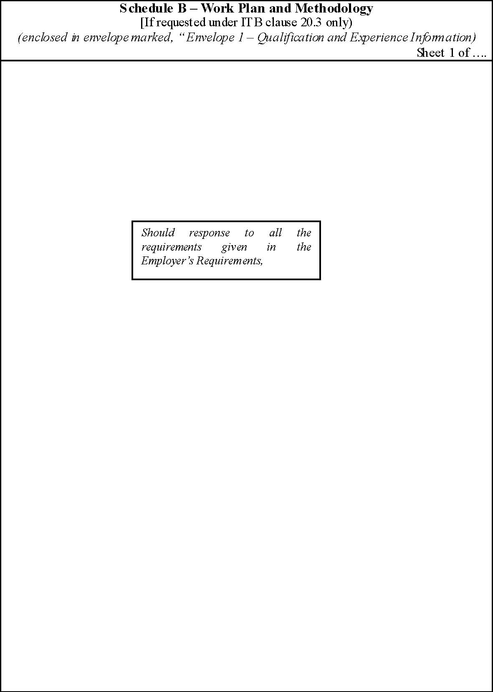

Schedule C – Key Staff

[If requested under IT B clause 2.3 only) (enclosed in envelope marked, “ Envelope 1 – Qualification and Experience Information)
Name | Position | Task

Schedule D –Equipment Proposed [If requested under IT B clause 2.3 only) (enclosed in envelope marked, “ Envelope 1 – Qualification and Experience Information)
Type | Capacity | Number

Schedule E – Client’s Reference

[If requested under IT B clause 2.3 only)
(Enclosed in envelope marked, “Envelope 1 – Qualification and Experience Information)

ATTACH THE CERTIFICATION GIVEN BY THE CLIENT’S, MAKING REFERENCES ON THE SERVICES EXECUTED BY THE BIDDER
Schedule F – Annual Turnover Information
(Last Three years)
[If requested under IT B clause 2.3 only)
(enclosed in envelope marked, “ Envelope 1 – Preliminary Information)
Year |  |  | Turnover | Remarks
1 |  |  |  | Attach audited reports
2
3

III. BID ENDORSEMENT
(Only on Bidder’s Letterhead)
Tender No: CSCL/JS/2026
The Chairman
Departmental Procurement Committee
Ceylon Shipping Corporation Ltd,
No.27, MICH Building,
Sir Razik Fareed Mawatha,
Colombo 01.

I/We, the undersigned, hereby confirm our full understanding and acceptance of the terms, conditions, and instructions detailed in the referenced Bid. We further commit to providing the services specified therein, in strict accordance with the terms outlined, and at the premium rate indicated in our policy.

Additionally, we acknowledge that the Company reserves the right, at its discretion, to reject any or all bids or to accept any portion of a bid that best serves the Company’s interests, without obligation to provide justification. We also understand that the Company is not required to accept the lowest bid.

Name of the Bidder:
Bidder’s Business Registration No:
Authorized Signature of the Bidder:
Name & Title of the Authorized Signatory:
Address:
Telephone and Fax Nos.: | Telephone Nos.:
 | Fax Nos.:
Address:
Date:
Seal:

IV. BID AFFIDAVIT OF NON-COLLUSION
AFFIDAVIT OF NON-COLLUSION

I,…………………………………………………………………...…..…(NIC No:…………………………..) of ………………………………………...……(Address)………………………, in the Democratic Socialist Republic of Sri Lanka, being the duly authorized representative (as bidder) of………………………...................(Name of Bidder)…………………………………………………(Address of Bidder)………………….do hereby solemnly, sincerely, and truly declares and affirms/makes an oath and states as follows;

1. That the bid submitted by us for the “INVITATION FOR BIDS TO PROVISION OF JANITORIAL SERVICE TO CEYLON SHIPPING CORPORATION LTD”, Tender No: CSCL/JS/2026 is made independently, and we have not entered into any agreement, understanding, arrangement, or practice with any other bidder, supplier, manufacturer, subcontractor, or any other person or entity, for the purpose of restricting competition or manipulating the bidding process.
2. That we have not disclosed, and will not disclose, the price, quotations, terms, or any other information relating to our bid to any other bidder or competitor, whether directly or indirectly, prior to the official opening of bids.

3. That we have not attempted, nor will attempt, to influence the procurement process through bribery, inducements, gifts, commissions, or any corrupt, fraudulent, collusive, or coercive practice as defined under the Sri Lanka Procurement Guidelines – 2025.

4. That no employee, board member, consultant, or advisor of the Procuring Entity has been offered or will be offered any benefit by us or by any person or entity acting on our behalf.

5. That we have fully complied with all provisions related to ethics, integrity, and anti-corruption under the Procurement Guidelines 2025 and any other applicable laws of Sri Lanka.

6. That this affidavit is made in good faith, with the full understanding that any false declaration may result in immediate rejection of our bid, or forfeiture of bid security, or blacklisting in accordance with Government regulations or legal action according to the laws of Sri Lanka.

7. That I hereby affirm, under the penalties for perjury, that all statements made by me in this affidavit are true and correct.

The foregoing Affidavit having been
duly read over and explained by me to
the Affirmant above named and he/she
having understood the contents therein
and admitted to be correct, affirmed and
set his/her signature hereto before me)
on this ……. day of ……..2026 at ………..
BEFORE ME,

JUSTICE OF THE PEACE/COMMISSIONER OF OATHS

V. BID SECURITY GUARANTEE
(Only on Bidder’s Letterhead)
Tender No: CSCL/JS/2026
The Chairman
Departmental Procurement Committee
Ceylon Shipping Corporation Ltd,
No.27, MICH Building,
Sir Razik Fareed Mawatha,
Colombo 01.

PROCUREMENT GUIDELINE REFERENCE 5.3.13
Format for Bid Security Guarantee
[this Bank Guarantee form shall be filled in accordance with the instructions indicated
in brackets]
----------------------------------- [insert issuing agency’s name, and address of issuing branch or office] -----

Beneficiary : ------------------------[insert (by PE) name and address of Employer/Purchaser]
Date : ------------[insert (by issuing agency) date]
BID Guarantee No: ----------------[insert (by issuing agency) number]
We have been informed that ----------------- [insert (by issuing agency) name of the Bidder: if a joint
venture, list complete legal names of partners] (hereinafter called “the Bidder”) has submitted to
you its bid dated ------------- [insert (by issuing agency) date] (hereinafter called “the Bid”) for the
execution/supply [select appropriately] of [insert name of Contract] under Invitation for Bids No.
-------------------- [insert IFB number] (“the IFB”).
Furthermore, we understand that, according to your conditions, Bids must be supported by a Bid
Guarantee.
At the request of the Bidder, we --------------------- [insert name of issuing agency] hereby irrevocable
undertake to pay you any sum or sums nor exceeding in total an amount of ------------------ [insert
amount in figures]-----------------[insert amount in words]upon receipt by us of your first demand in
writing accompanied by a written statement stating that the Bidder is in breach of its obligation(s)
under the bid conditions, because the Bidder :

- has withdrawn its Bid during the period of bid validity specified ; or
- does not accept the correction or errors in accordance with the Instructions to
Bidders (hereinafter “the ITB”) of the IFB ; or
- having been notified of the acceptance of its Bid by the Employer/Purchaser during the
period of bid validity, (i) fails or refuses to execute the Contract Form, if required, or (ii)
fails or refuses to furnish the Performance Security, in accordance with the ITB.

This Guarantee shall expire : (a) if the Bidder is the successful bidder, upon our receipt of copies
of the Contract signed by the Bidder and of the Performance Security issued to you by the Bidder,
or (b) if the Bidder is not the successful bidder, upon the earlier of (i) our receipt of a copy of your
notification to the Bidder that the Bidder was unsuccessful, otherwise it will remain in force upto
--------------------- (insert date)
Consequently, any demand for payment under this Guarantee must be received by us at the office
on or before that date ___________________________

[signature(s) of authorized representative(s)]

VI. SCHEDULE OF REQUIREMENT
(Only on Bidder’s Letterhead)
Tender No: CSCL/JS/2026
Number of Janitors and Supervisors required per day at the premises locations are as follows; (These requirements are the day to day needs).
Description Head Office Premises
Head Office Premises
No.27, MICH Building
Sir RazikFareedMawatha
Colombo 01

=============== ====================
Number of floors Three (03)

Number of Janitors Three (03)

Number of One (01)
Supervisors

Note
Working Hours on Weekdays: from 7.00 a.m. to 4.30 p.m.

Saturdays: from 7.00 a.m. to 1.00 p.m.

